

**CIS 11042 – Practical for Essential of ICT and PC Applications**

Information and communication Technology

Faculty of Technology

South Eastern University of Sri Lanka

Registration Number: SEU/IS/22/ICT/075

Academic year: 22/23

**Challenge Question**

1. Open ms Word 🡪 file 🡪 more templates 🡪 search for “job offer letter” 🡪 select one 🡪 ”Create”

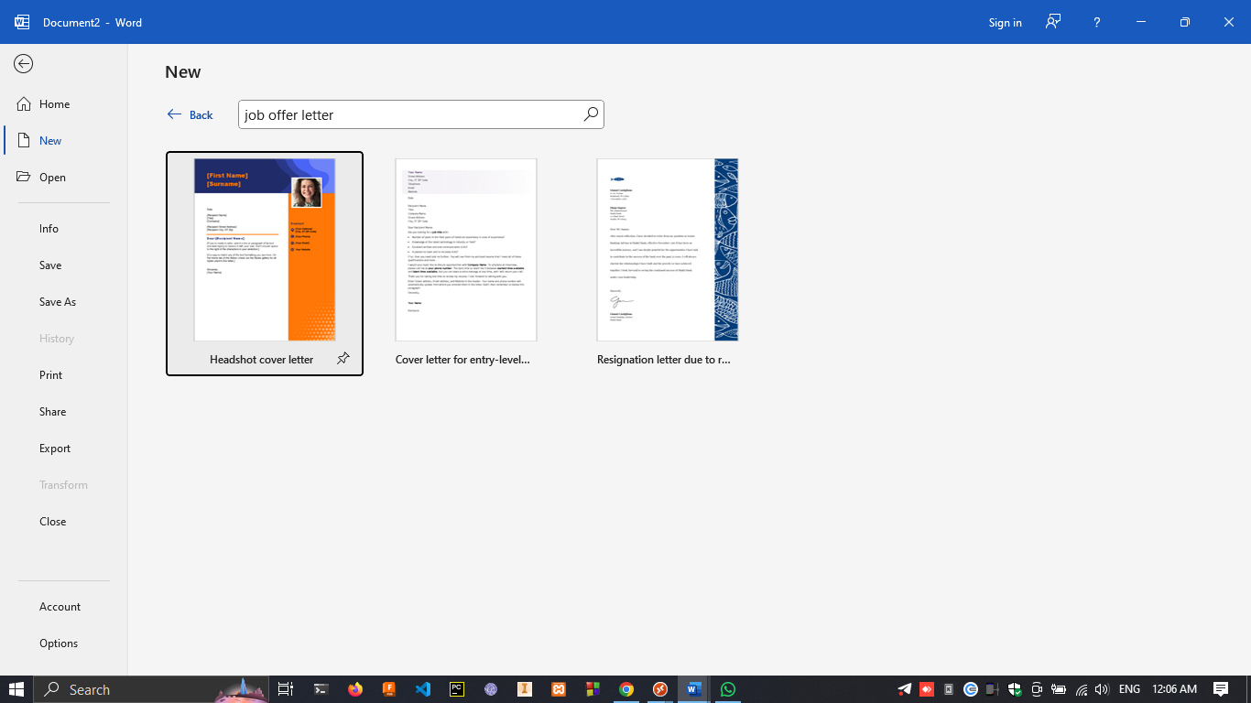

1. File 🡪 save as 🡪 this pc 🡪 select location 🡪 name it as “JobOffer1.docs” 🡪 save

File 🡪 save as 🡪 this pc 🡪 select location 🡪 name it as “JobOffer2.docs” 🡪 save

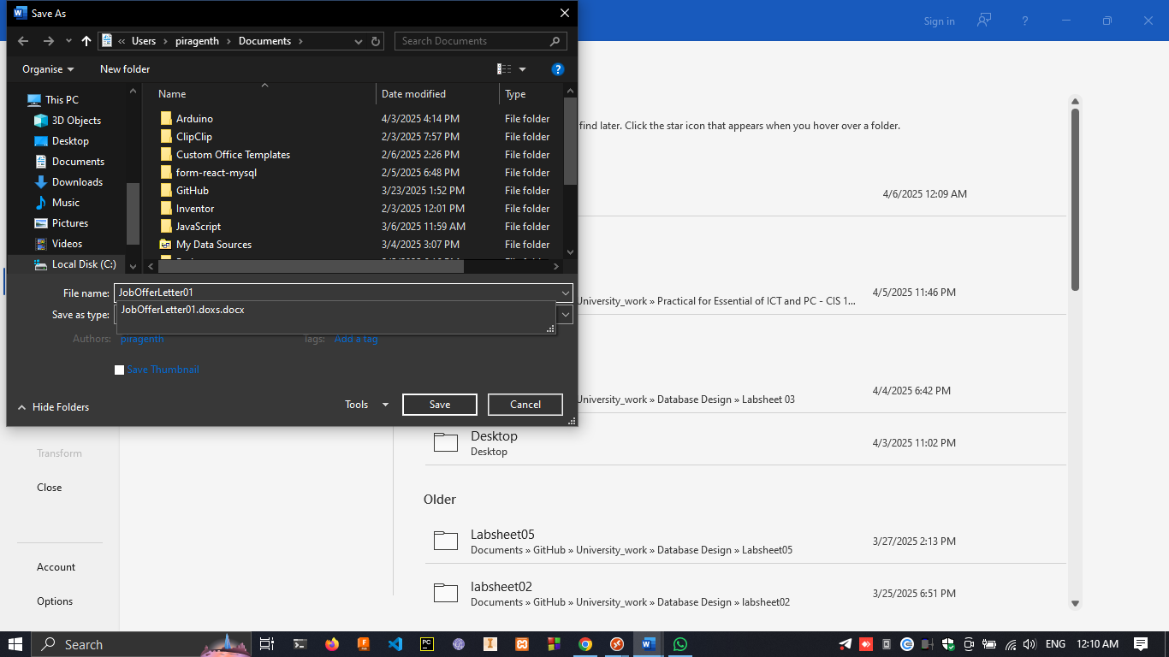

1. Mailings 🡪 start mail merge 🡪 select the type.

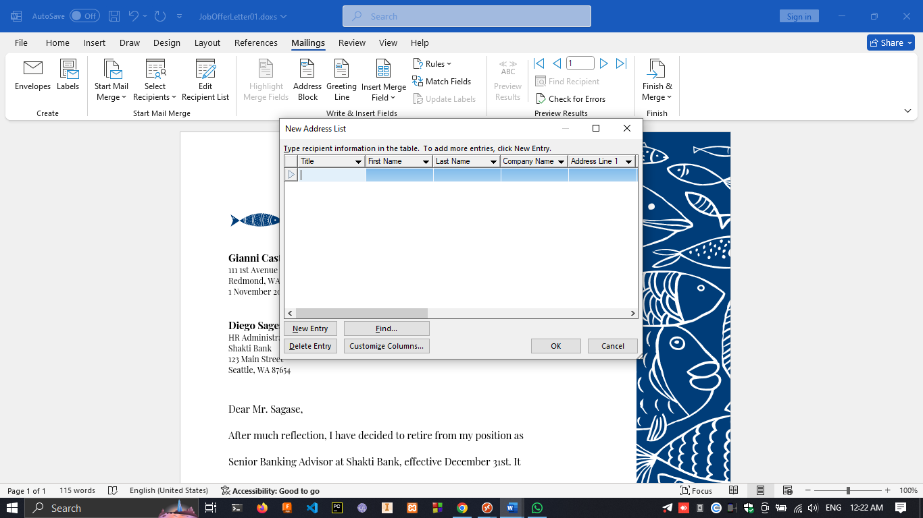

1. mailing → Rules → if…then…else… → select (filed name & competition) → type “miss” → click ok.

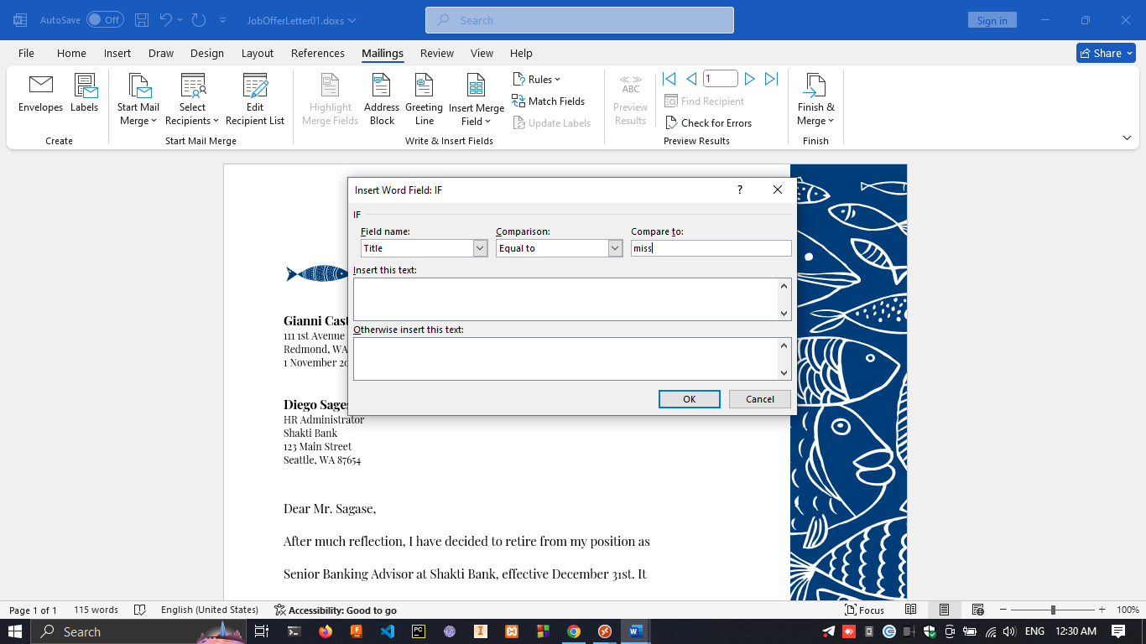

1. mailing → finish & merge → edit individual document → tick 3 rd option as in picture → “from 4 to 4” (you can set range as you wish) → click ok.

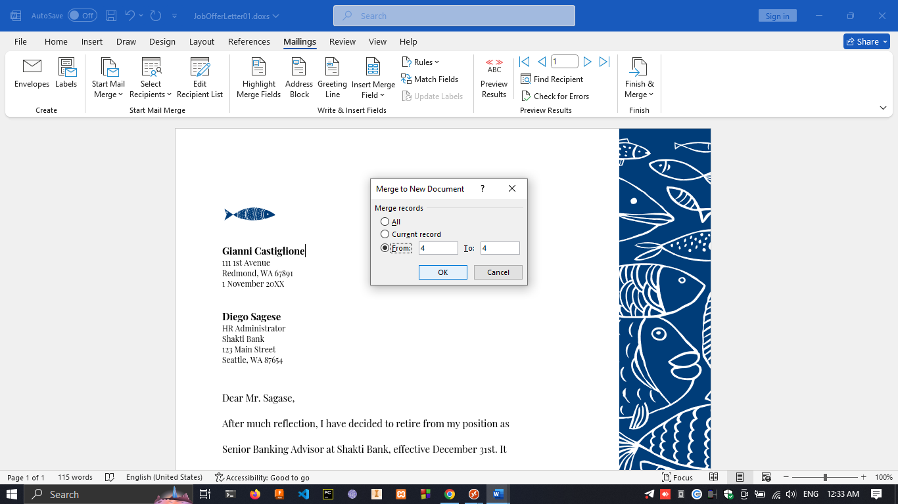

1. file 🡪 check for issues 🡪 info 🡪 inspect Documents.

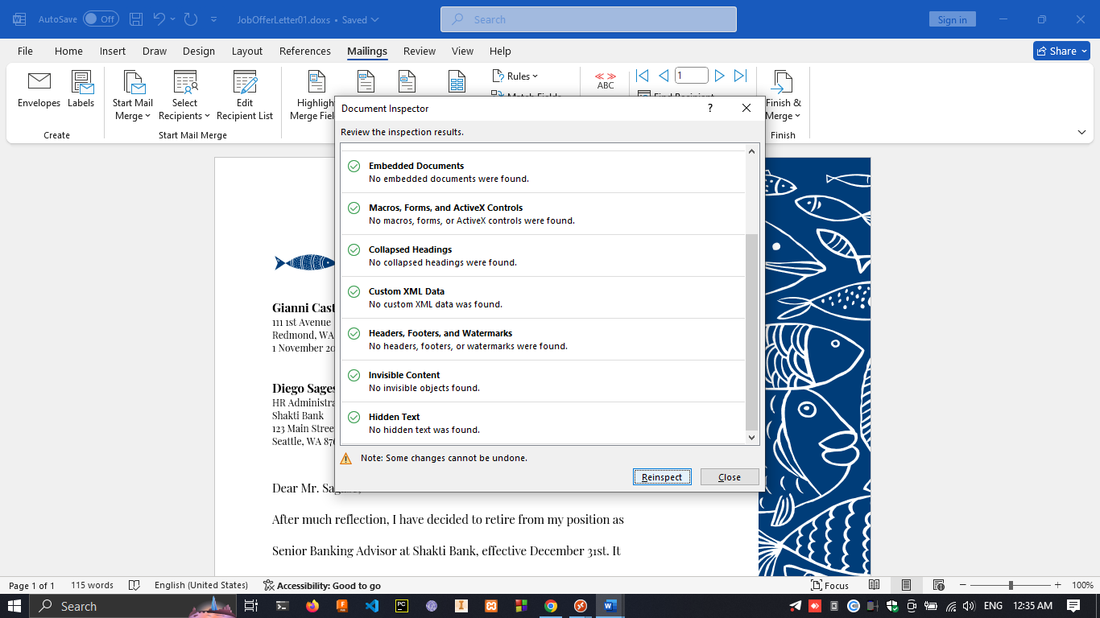

1. file 🡪 info 🡪 make as Final 🡪 click ok

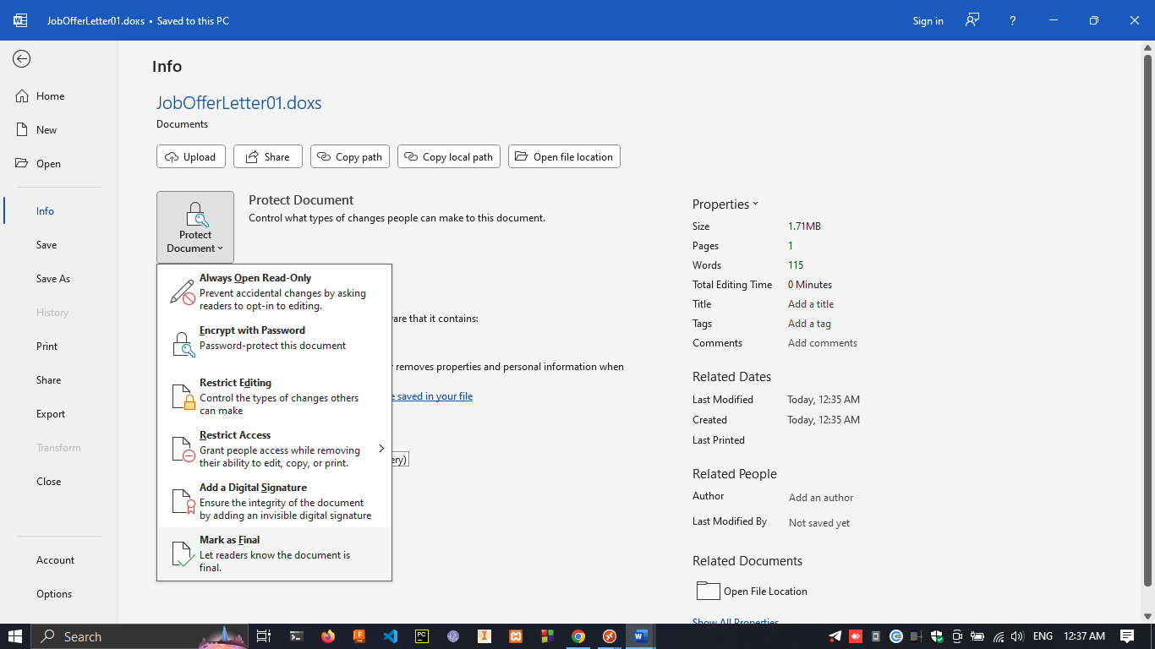

1. File → Info → Protect Document → Encrypt with Password → “secure123” → confirm.

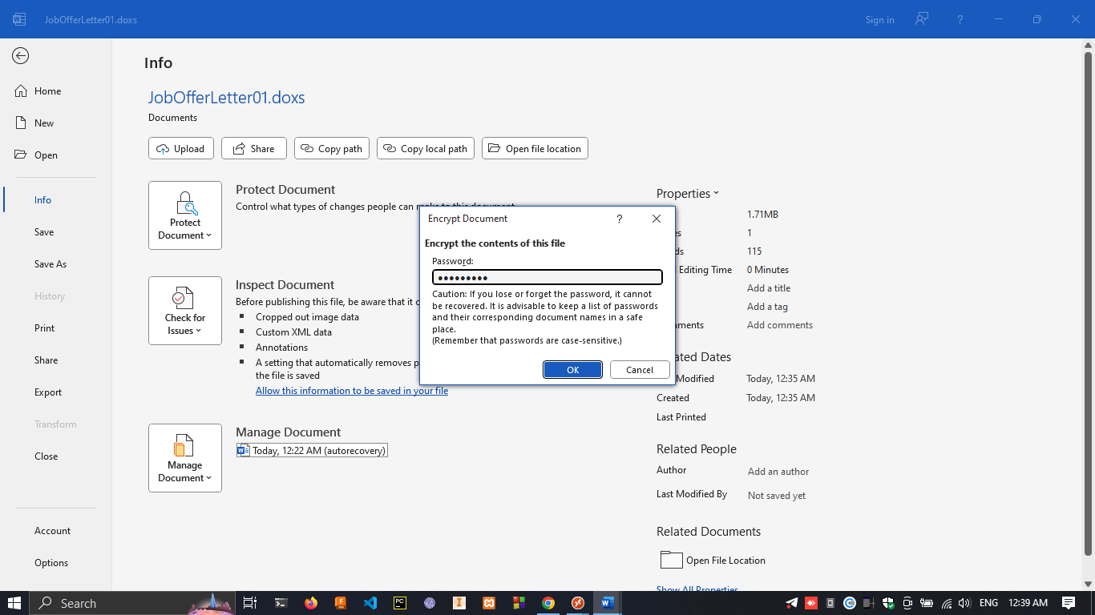

1. Under the “Jobofferletter01.docs” 🡪 review 🡪 compare 🡪 select “Jobofferletter02.docs” to compare with “Jobofferletter01.docs”

